Commentary

Electoral maps cheat minorities
By ANA MARÍA ARCHILA - Ana María Archila is the co-executive director of Make the Road New York, the largest participatory immigrant organization in New York, which has offices in Suffolk County, Queens, Brooklyn and Staten Island.

February 1, 2012

How much does your vote count?
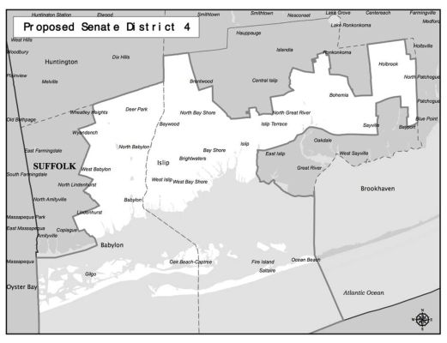
New York State Senate District 4 map proposed in January 2011 by the NYS Legislative Task Force on Demographic Research and Reapportionment

"As much as anyone else's," you might think. But it's not so simple. The voting power of individuals and communities all hinges on geography.

Every 10 years, America's political landscape changes. Following the census, levels of government draw new district lines to reflect changing demography. Among other factors, the law says newly drawn districts should reflect population changes while remaining compact and keeping intact "communities of interest" -- that is, groups living near one another with commonalities such as racial and ethnic background or economic interests.

But, too often, partisan efforts to protect incumbents dictate redistricting. And the biggest victims are usually communities of color.

Sadly, history appears to be repeating itself in New York. Last week, the New York State Legislative Task Force on Demographic Research and Reapportionment released proposals for new state Assembly and Senate districts. The proposed maps appear awash with politically manipulated boundaries and give short shrift to Long Island's burgeoning population of racial and ethnic minorities.

Just look at Suffolk County. From 2000 to 2010, census data show that Suffolk's population increased by roughly 75,000 people. But Suffolk's population would have declined if not for increased Latino, immigrant and African-American populations. Ideally, new district maps would ensure that these growing communities receive greater political representation. They should keep neighboring groups together in the same district so that, as a bloc, they could elect the legislators they feel would best represent them. The legislative task force's maps, however, propose parceling them up into disparate, majority-white districts.

The most egregious example is the Town of Islip, where the proposed State Senate map would again carve Central Islip and Brentwood up into different districts, diluting the power of these overwhelmingly African-American and Latino communities.

Before the legislature released its proposals, Common Cause New York, a nonprofit, nonpartisan advocacy organization, proposed maps that would better reflect Suffolk's demography and keep the voting power of communities of color intact. Common Cause argued that Central Islip and Brentwood should be combined with Wyandanch and other areas of Babylon to create a nearly majority-minority State Senate district. Instead, the legislature divided up these three majority-minority communities into three Senate districts.

Ultimately, Gov. Andrew M. Cuomo should veto the legislature's maps and ensure that new districts respect communities of interest. A better redistricting process, as the governor has insisted, would be done by an independent commission that isn't beholden to either party and instead seeks to create fair and competitive districts.

Such changes require political leadership, however, and many legislators have already backtracked on their pledges to support independent redistricting. So we need grassroots pressure. Community organizations must educate their members and clients and make sure their voices are heard.

The legislative task force, which inexcusably delayed the release of its maps, has given the public only a matter of days to analyze them and prepare for public hearings. On Long Island, the hearing is scheduled for Feb. 9.

Before then, we must inform ourselves about these maps. One such opportunity will come on Monday, when the Long Island Civic Engagement Table (a nonpartisan initiative to promote civic participation), Long Island Wins (an organization focused on immigration issues) and Noticia, a Spanish-language weekly newspaper, will hold a community forum in Brentwood to examine the impact of these proposals on Latino, immigrant and African-American communities.

If we don't raise our voices now, the consequences could be dire. Whatever maps are approved will be in place for another decade. That's a long time for Long Island's communities of color to remain undercounted and underrepresented.

The Long Island Civic Engagement Table, Long Island Wins and Noticia community forum on the proposed maps will be held at 1090 Suffolk Avenue in Brentwood on Monday, Feb. 6, at 6:30 p.m.

The New York State Legislative Task Force on Demographic Research and Reapportionment will hold a public hearing 11 a.m. Thursday, Feb. 9, at the Suffolk County Legislature William H. Rogers Legislative Building, 725 Veterans Memorial Hwy., Hauppauge.

Each hearing will be recorded and available for viewing at latfor.state.ny.us. The new Senate and Assembly district lines are also available at the same website. Anyone wishing to provide written input can contact the task force by email at info@latfor.state.ny.us or by mailing to LATFOR, 250 Broadway, Suite 2100, New York, NY 10007.

